Language Arts Links

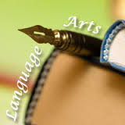

Book Adventure
Education World: The Reading Machine
Fun Brain
Good Sites for Kids
Mr. Nussbaum
National Geographic Kids
Neo K-12
PBS Kids
Room Recess
Scholastic Kids
Sheppard
Storyline Online
Storytime for Me
The Kidz Page
Time for Kids

